Ex. no: 2a)
Date:
Shell Script
Aim:
To write a Shellscript to to display basic calculator.

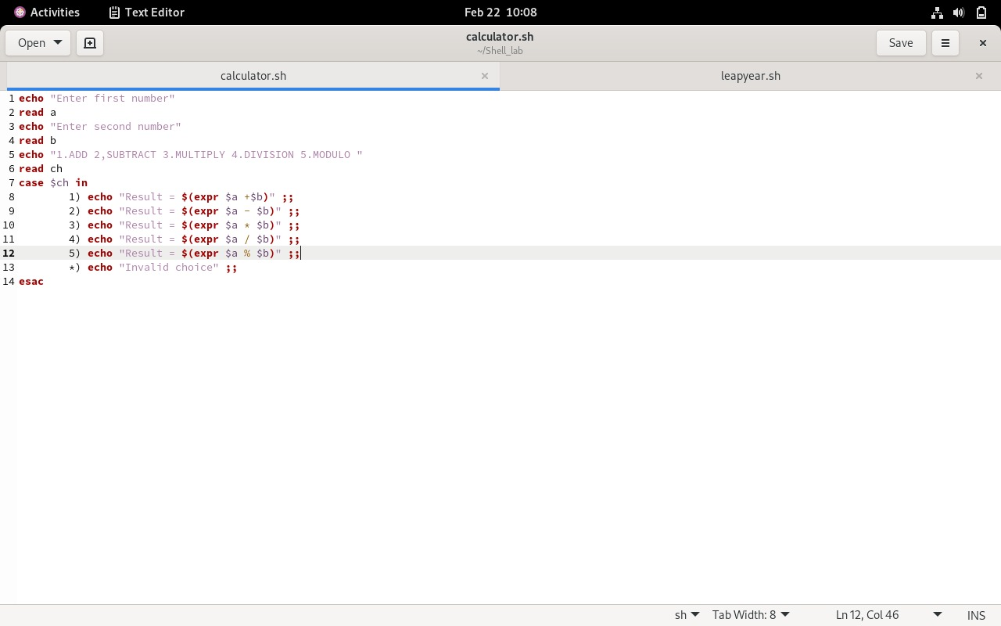
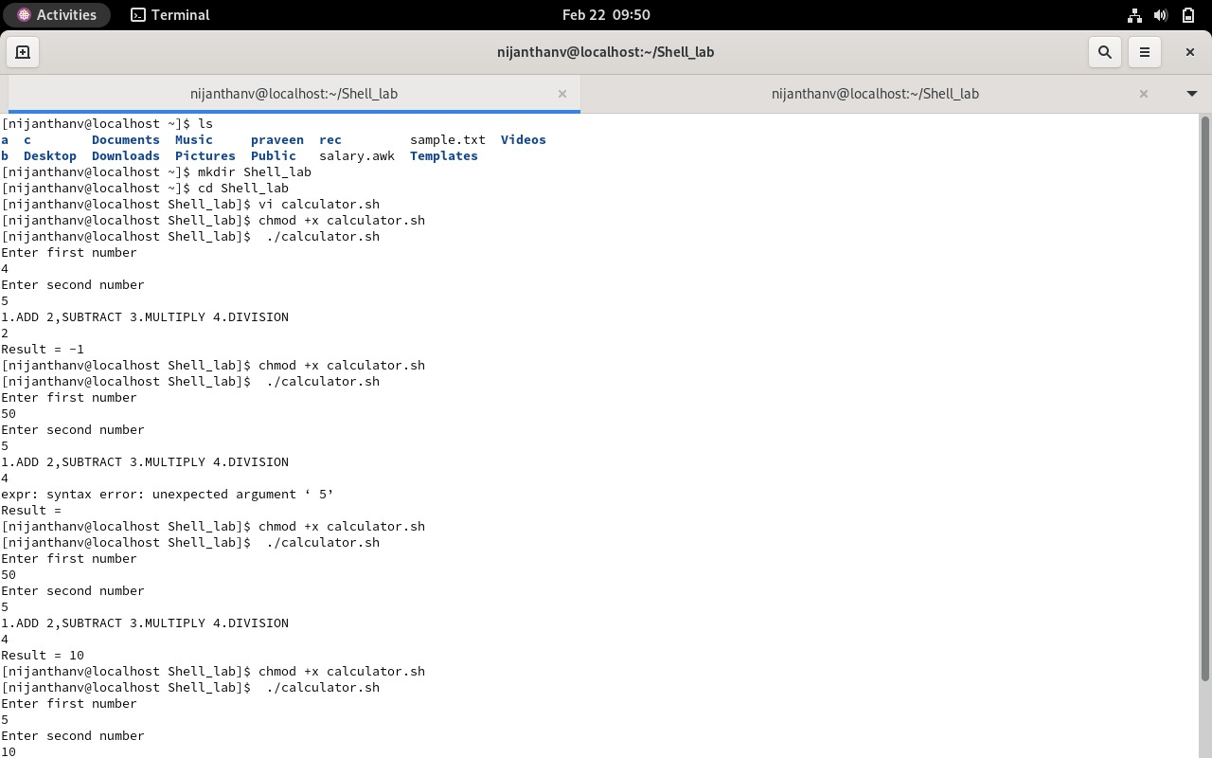
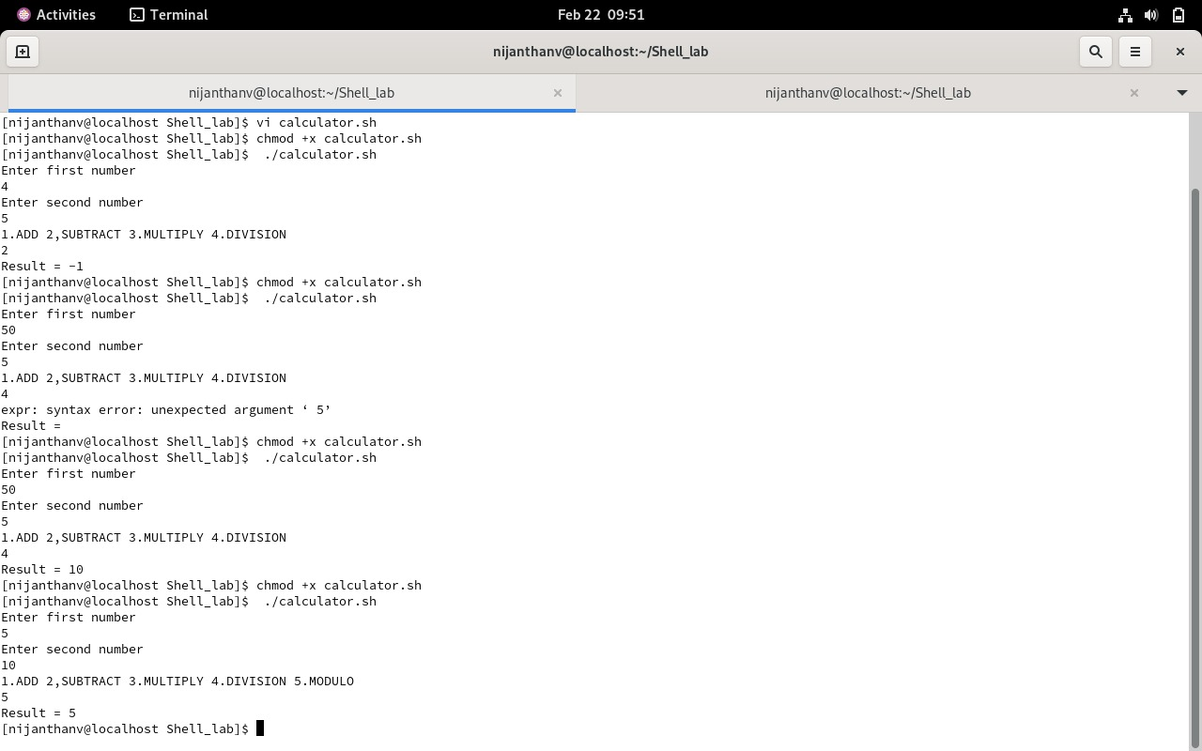

Ex. no: 2b)
Date:
Shell Script
Aim:
To write a Shellscript to test given year is leap or not using conditional statement

